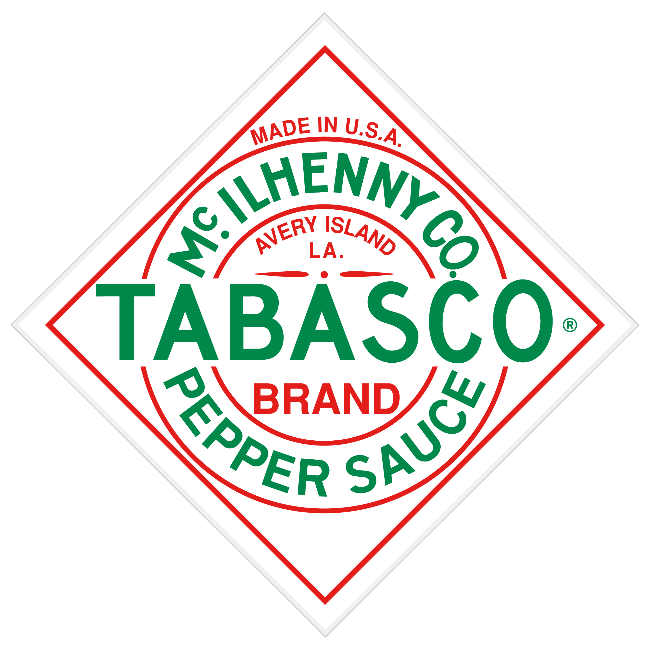

TABASCO® Brand Scripts + Guidelines

OVERVIEW
We have produced two long format, cinematic digital films telling two distinct stories about the TABASCO® Brand. Below please find the individual scripts to translate for you individual language needs. In addition to the TABASCO® Brand Portal, they current live on the US YouTube page.

TRANSLATION GUIDELINES
Please translate the narrative using subtitles versus a voice over. The suggested font is Noto Serif Regular.

TABASCO® Original Red Sauce: Over a Century of Tradition – An Eye to the Future
http://bit.ly/1QSsJhW
1 minute 35 seconds

It’s where craftsmen work with soil, water, peppers and salt. It’s where a century of tradition meets with an eye to the future. Where laurels are celebrated but never rested upon.

It’s a place called Avery Island, Louisiana. And it’s the only place where TABASCO® Original Red Sauce can be made. Since the 1860s the world has changed a lot but one thing that hasn’t changed is the way we make our one-of-a-kind sauce.
The handpicked peppers are mashed, mixed with a small amount of salt then placed in white oak barrels. The barrels are then sealed and the pepper mash is aged for up to three years. The aging gives the sauce its character by allowing the flavors to evolve. After aging, the mash is then ready to be stirred with vinegar and bottled.
And while Original Red is enjoyed on tables around the world…it always starts right here… on Avery Island. There are easier ways, but for McIIhenny Company… this is the only way.

